David Flores

5/28/2023

CST 259

Activity 4

* [Github link](https://github.com/dflores52/Activity4)
* [Youtube link](https://youtu.be/5zHVOaj1HfI)
* What I learned?
  + I learned through outside research how to incorporate the json libraries through the maven process. I did experience a lot of trouble adding those in and did get the error message that they were not accessible through the build path process.
* What was challenging
  + Like I said above the main issue I had was importing the libraries through the buildpath option in eclipse I kept receiving the error that they were not accessible.
* What would I do if I had more time?
  + Through my research I do feel like I have a better understanding of what json is.
* Part 1a
  + Correct File name and output A screenshot of a computer

    Description automatically generated with low confidence
  + Screen shot of incorrect file name A black background with white text

    Description automatically generated with low confidence
  + Screenshot of output fileA screenshot of a computer

    Description automatically generated with low confidence
* Part 1b
  + Console messageA black background with white text

    Description automatically generated with low confidence
  + OutFile.txtA screenshot of a computer

    Description automatically generated with medium confidence
* Part 1c
  + A screenshot of a computer

    Description automatically generated with medium confidenceA screenshot of a computer

    Description automatically generated
* Part 2
  + Json file generated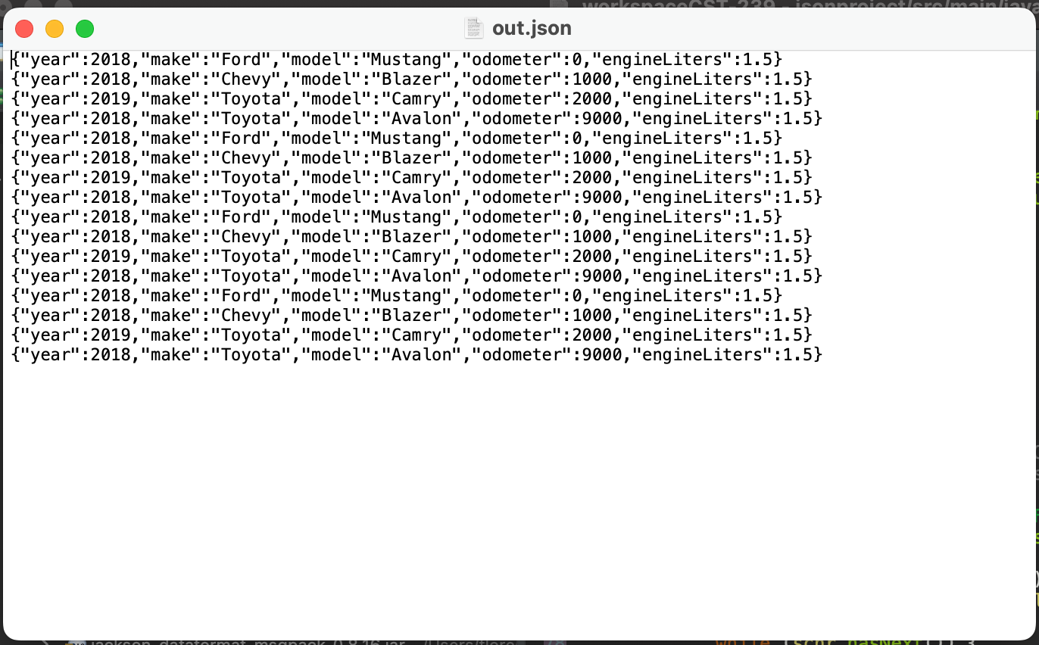
  + Console output 